**All Single layer Perceptron Algorthm performed by Matthew McKernan, ID: 17321381**

We divided the work so Matthew McKernan completed all things related to single-layer perceptron and Anagha completed all work for multi-layer perceptron.

**Algorithm and design decisions for Single layer Perceptron Algorthm:**

Data preparation:

We checked the value counts to make sure the data was relatively symmetric. We split data into train, test and validation. We normalised the data feature data. We converted yes/no to 1/0 so we could use it to train the weights later on.

**Perceptron algorithm**

I created several functions to do some of the perceptron processes.

**Threshold algorithm:**

The threshold algorithm outputs yes or no depending on if the weighted sum of features and weights is greater than some step value.

**Weighted sum Algorithm:**

An algorithm that inputs the features row and weights and find the sum of the dots products

**Train weights on training data using formula w = w + x*r*(y_actual-y_predicted):**

It went through each row of the training data and updated the weights using the formula w = w + x*r*(y_actual-y_predicted). The weights were updated if they were different from the actual data. I used a correction term of 0.5. I tried out several correction terms and corresponding thresholds and this correction term seemed to give good results.

**Find what value to use to divide yes/no:**

I compared the weighted sum of several training rows and the actual output for that row. I picked a number that seemed to divide most of the yes/no outputs for the threshold. Later on I used a learning curve to find the best value for the threshold. The best value I found was 0.99.

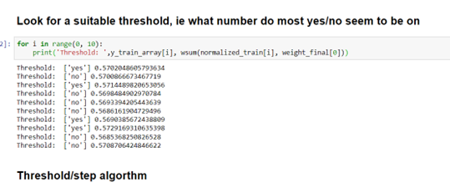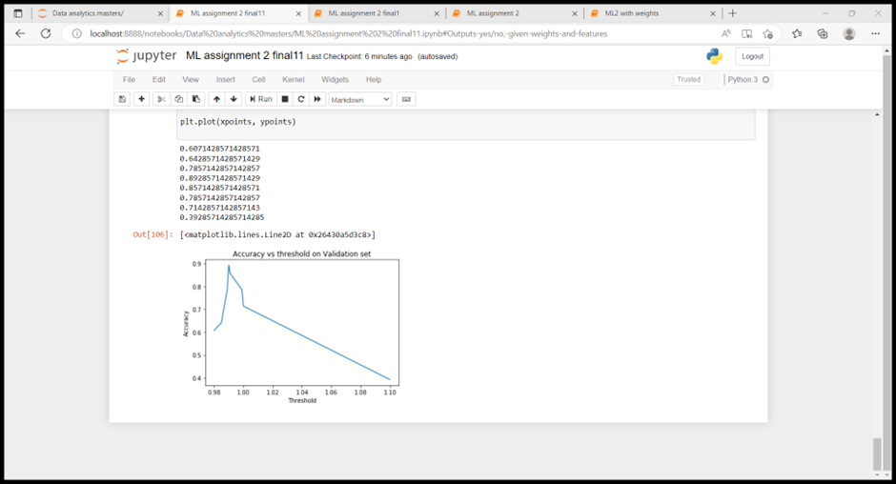

**The perceptron algorithm:**

The algorithm inputs the trained weights, feature data and what step size to use for the threshold. It outputs an array containing yes/no for each row. For each row of feature data, find the weighted sum, see if the weighted sum is above or below a threshold and output yes/no to an array.

**Testing, results and Conclusions:**

**What features hold the most weight:**

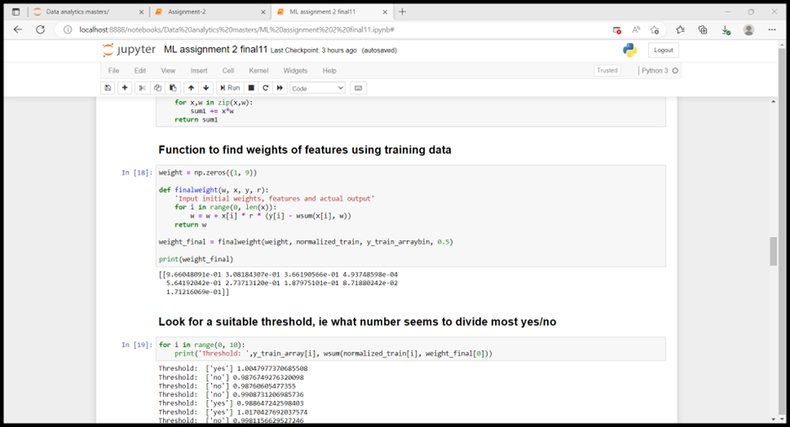

| **Feature** | year | temp | humidity | Rainfall | drought_code | buildup_index | day | month | wind_speed |
| --- | --- | --- | --- | --- | --- | --- | --- | --- | --- |
| **Weight** | 0.966 | 0.308 | 0.366 | 4.93748598e-04 | 0.5641 | 0.273 | 0.188 | 0.087 | 0.171 |

Rainfall was the worst predictor of wildfires. Year was the best predictor of wildfires, but it couldn’t have caused fires directly. I assume it is following a trend of greater wildfires from global warming over time.

**Accuracy of model:**

I tested the accuracy of the model on training, validation and testing sets. I used classification report, confusion matrix and accuracy score. The accuracy scores were 0.69, 0.89 and 0.78 for testing, validation and testing sets respectively.

**Accuracy Curve:**

I plotted an accuracy curve to find the best threshold to divide yes/no data. I used the validation set. The most accurate value seemed to be a threshold of 0.99. If the weighted sum of a row is greater than this it’s classified as yes and if it’s less than this it’s classified a no.



**Comparison of my algorithm with reference:**

I used a reference algorithm from Sklearn. The following table compares the accuracies of the two algorithms.

|  | My algorithm | Reference |
| --- | --- | --- |
| Train | Accuracy: 0.69 | Accuracy: 0.87 |
| Validation | Accuracy: 0.89 | Accuracy: 0.75 |
| Test | Accuracy: 0.78 | Accuracy: 0.56 |

My algorithm from scratch outperformed the reference algorithm for validation and testing sets.

All the results are from random state = 5

I repeated this for 4 other random states , random states =1,2, 3,4

The testing accuracies for my algorithm were: 0.51, 0.42, 0.48, 0.42

The testing accuracies for reference algorithm: 0.87, 0.66, 0.86, 0.81

My accuracies were very low because I would need to change my threshold for each random state. The model will work for any inputted data but not for any random state. If I had more time I could repeat my process and find an accuracy curve for each random state so find a good threshold for each of the random state.